**SPORTS LEAGUE:**

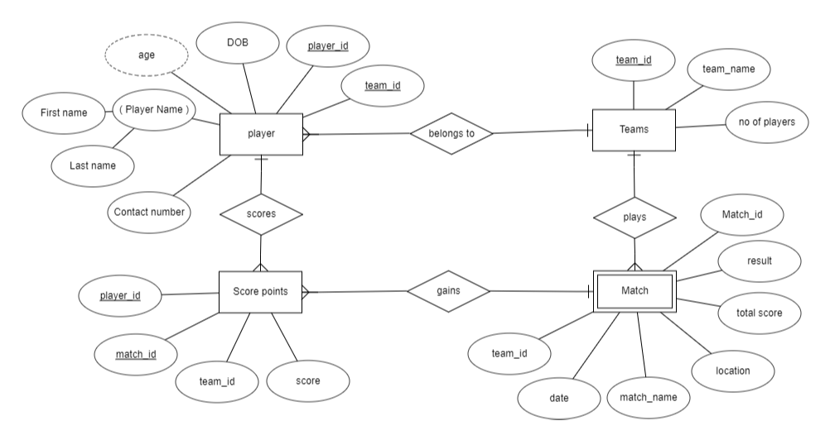

From this ER diagram we can infer that players belongs to different teams and many teams plays the match. The score points are stored and the result is updated.